**Lab#1(a) Creating a registration Page with HTML 5 Validation**

|  |  |  |
| --- | --- | --- |
| **TAGS USED** | **ATTRIBUTES USED** | **DESCRIPTION** |
| <HTML> | -- | Write the description of HTML tags and attributes |
| <HEAD> | -- | Write the title and meta tags here |
| <META> | CHARSET,NAME | Attribute of metadata |
| <TITLE> | BGCOLOR,TEXT, BACKGROUND | Write title of your website |
| <STYLE > | ALIGN |  |
| <BODY > | FACE,SIZE,COLOR |  |
| <FORM> | ACTION,METHOD | Attributes for user input and data submission |
| <LABEL> | FOR | Attribute of the  corresponding input element |
| <TD> | COLSPAN,ALIGN | Define cell in html table |
| <TR> | -- | Define row in table |

**Final Outcome:**

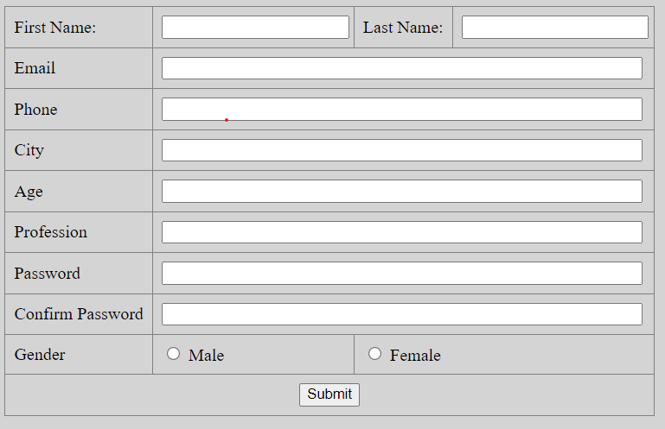

**Code Snippet:**

<!DOCTYPE html>

<html lang="en">

<head>

<meta charset="UTF-8">

<meta name="viewport" content="width=device-width, initial-scale=1.0">

<title>Registration Form</title>

<style>

body {

background-color: #333;

color: white;

}

table {

margin: 0 auto;

border-collapse: collapse;

}

td {

padding: 8px;

}

input[type="text"],

input[type="email"],

input[type="tel"],

input[type="password"] {

width: 98%;

}

</style>

</head>

<body>

<form action="#">

<table border="1">

<tr>

<td>First Name:</td>

<td><input type="text" name="first_name"></td>

<td>Last Name:</td>

<td><input type="text" name="last_name"></td>

</tr>

<tr>

<td>Email</td>

<td colspan="3"><input type="email" name="email"></td>

</tr>

<tr>

<td>Phone</td>

<td colspan="3"><input type="tel" name="phone"></td>

</tr>

<tr>

<td>City</td>

<td colspan="3"><input type="text" name="city"></td>

</tr>

<tr>

<td>Age</td>

<td colspan="3"><input type="text" name="age"></td>

</tr>

<tr>

<td>Profession</td>

<td colspan="3"><input type="text" name="profession"></td>

</tr>

<tr>

<td>Password</td>

<td colspan="3"><input type="password" name="password"></td>

</tr>

<tr>

<td>Confirm Password</td>

<td colspan="3"><input type="password" name="confirm_password"></td>

</tr>

<tr>

<td>Gender</td>

<td><input type="radio" name="gender" value="male"> Male</td>

<td colspan="2"><input type="radio" name="gender" value="female"> Female</td>

</tr>

<tr>

<td align="center" colspan="4"><input type="submit" value="Submit"></td>

</tr>

</table>

</form>

</body>

</html>